Federated Machine Learning for Predicting Animal to Human Zoonotic Disease Outbreaks

Abstract

Zoonotic diseases, which spread from animals to humans, pose significant health challenges. Early detection of potential outbreaks is essential to minimize health risks and economic losses. This project proposes a federated machine learning framework to predict zoonotic disease outbreaks while preserving data privacy. The system integrates distributed datasets from farms, hospitals, and wildlife monitoring clients, including features such as animal population, human-animal contact, reported cases, and wildlife migration. A federated deep neural network (FDNN) is trained locally on each client, and model updates are aggregated using Federated Averaging (FedAvg) to form a global model. The learned representations are further processed using gradient-boosted decision trees (XGBoost/ CatBoost) to enhance prediction accuracy. A dataset of 10,000 rows was getting to simulate client data contributions. The final system is deployed using Flask, offering a user-friendly interface with home, about, login, registration, prediction, and prediction history pages. The application securely handles user inputs, stores prediction history in SQLite, and provides accurate outbreak risk classification. This framework demonstrates a practical, privacy-preserving, and effective approach for early zoonotic disease detection.
Keywords: zoonotic diseases, federated learning, deep neural network, FedAvg, gradient-boosted trees, outbreak prediction, Flask deployment, privacy preservation, epidemic risk.

Introduction

Zoonotic diseases are infections that are transmitted between animals and humans, posing serious threats to public health, agriculture, and global economies. The increasing interaction among humans, livestock, and wildlife, along with environmental changes, has intensified the risk of disease spillover events. Early identification of outbreak risks is essential to reduce transmission, support preventive planning, and improve emergency response strategies. However, predicting zoonotic outbreaks remains complex due to the diverse and distributed nature of the contributing data sources.
Recent advances in machine learning have demonstrated strong potential for analyzing large-scale health and environmental data. Traditional centralized learning approaches require all data to be collected in a single location, which raises concerns related to data privacy, ownership, and regulatory compliance. These challenges are particularly critical in healthcare and epidemiology, where sensitive clinical records and surveillance data cannot be freely shared across institutions.
Federated learning has emerged as an effective solution to address these limitations by enabling collaborative model training without exchanging raw data. In a federated setting, local models are trained independently at different data sources, and only model updates are shared with a central server. This approach preserves data privacy while still benefiting from knowledge across multiple domains, making it well suited for zoonotic disease surveillance involving farms, hospitals, and wildlife monitoring systems.
Deep neural networks are widely used for modeling complex and non-linear relationships in high-dimensional data. When applied locally in a federated learning framework, these models can capture meaningful patterns within each data source. However, deep models often lack interpretability and may struggle to generalize effectively when used alone, particularly in risk classification tasks that require clear decision boundaries.
To address these challenges, hybrid learning approaches have gained attention by combining deep learning with tree-based ensemble models. Deep neural networks can be used to extract high-level feature representations, which are then provided as inputs to gradient boosted decision trees such as XGBoost or CatBoost. This combination improves classification accuracy while offering better interpretability and robustness.
This work presents a federated hybrid learning framework for zoonotic disease outbreak risk prediction using distributed farm, hospital, and wildlife data. The proposed system integrates federated deep neural networks with gradient boosted decision trees to achieve accurate and privacy-preserving risk classification. Experimental results demonstrate that the proposed approach effectively captures cross-domain patterns and provides reliable outbreak risk predictions suitable for real-world decision support systems.

Problem Statement

The early prediction of zoonotic disease outbreaks is a critical challenge due to the complex interaction between human health, animal populations, and environmental factors. Data related to disease surveillance are often distributed across farms, hospitals, and wildlife monitoring systems, making centralized data collection difficult. In addition, these datasets are highly sensitive and subject to strict privacy, ethical, and regulatory constraints, which limits data sharing and reduces the effectiveness of traditional predictive modeling approaches.

Existing machine learning models for outbreak prediction largely rely on centralized architectures that require direct access to raw data. Such approaches introduce significant risks related to data leakage, ownership conflicts, and compliance violations. Moreover, models trained on isolated datasets often fail to capture cross-domain patterns, leading to reduced generalization performance when predicting outbreaks across diverse ecological and epidemiological settings.

Another major limitation of current systems is the lack of interpretability and robustness in predictive outcomes. Deep learning models can achieve high accuracy but operate as black boxes, while conventional models may not fully capture complex feature interactions. Therefore, there is a need for a secure, accurate, and explainable learning framework that can integrate distributed data sources while preserving privacy and delivering reliable outbreak risk predictions.

Specifically, the main aim of this work is to:
- Develop a privacy-preserving federated learning framework for zoonotic disease outbreak prediction using distributed data sources.
- Design a hybrid modeling approach that combines federated deep neural networks with gradient boosted decision trees for improved accuracy and robustness.
- Enable effective feature extraction from complex epidemiological and environmental data using deep learning.
- Provide model explainability through feature contribution analysis to support transparent decision-making.
- Evaluate the proposed framework across multiple real-world data domains such as farms, hospitals, and wildlife systems.

Significance

This work is significant as it addresses the critical challenge of predicting zoonotic disease outbreaks while preserving data privacy across multiple stakeholders. By adopting a federated learning framework, the proposed system enables collaborative model training among farms, hospitals, and wildlife monitoring units without requiring the exchange of raw data. This approach enhances trust, ensures regulatory compliance, and promotes secure data utilization in sensitive health-related domains.

The integration of deep neural networks with gradient boosted decision trees further strengthens the predictive capability of the system by combining automated feature learning with robust decision-making. Additionally, the incorporation of explainability techniques improves model transparency, allowing public health authorities to understand contributing risk factors and make informed intervention decisions. Overall, the proposed framework supports early outbreak detection, scalable deployment, and privacy-aware analytics, making it highly valuable for real-world epidemiological surveillance and public health planning.
Challenges

Predicting zoonotic disease outbreaks using distributed data sources presents several technical and operational challenges. The data collected from farms, hospitals, and wildlife systems are highly heterogeneous, incomplete, and often noisy, which complicates preprocessing and model generalization. Ensuring consistent learning across clients while preserving data privacy adds further complexity, particularly when client data distributions are imbalanced. In addition, achieving high predictive accuracy without centralized data access requires careful model design, efficient aggregation strategies, and robust feature representation. Interpreting complex hybrid models and maintaining scalability in real-world deployments also remain significant challenges.

Key Challenges:
- Heterogeneity of data across farm, hospital, and wildlife clients
- Presence of missing values, skewed distributions, and outliers
- Class imbalance in outbreak risk levels
- Privacy preservation without sharing raw data
- Federated model convergence and synchronization issues
- Integration of deep learning with tree-based models
- Computational and communication overhead in federated training
- Ensuring model explainability and trustworthiness

Literature & Comparative studies

Many researchers and practitioners have explored the use of machine learning and data-driven approaches for predicting complex real-world events such as employee churn, customer attrition, and disease outbreaks. Similar to churn prediction systems, zoonotic disease outbreak prediction also involves identifying early warning signals from large, heterogeneous datasets and understanding the factors that influence risk levels. Several studies emphasize that the effectiveness of predictive systems largely depends on feature selection, data quality, and the ability of models to generalize across different populations and environments.

Early research in disease outbreak prediction focused on traditional statistical and epidemiological models, where historical case counts, environmental variables, and population data were used to forecast future outbreaks. However, these approaches often struggled with non-linear relationships and high-dimensional data. With the advancement of machine learning, researchers began applying algorithms such as logistic regression, decision trees, random forests, and support vector machines to improve prediction accuracy. These studies demonstrated that ensemble models outperform single classifiers by capturing complex interactions among features such as climate conditions, human mobility, and animal health indicators.

More recent studies have highlighted the role of deep learning in outbreak prediction, particularly for modeling temporal patterns and hidden representations in large datasets. Neural networks have been used to learn complex feature representations from epidemiological and environmental data, leading to improved predictive performance. However, a major limitation identified in the literature is the need for centralized data collection, which raises serious privacy and security concerns, especially when dealing with sensitive hospital and public health records.

To address privacy challenges, federated learning has emerged as a promising solution. Several comparative studies report that federated deep neural networks can achieve performance comparable to centralized models while ensuring that raw data remains local to each client. Research also shows that federated averaging (FedAvg) effectively aggregates knowledge from distributed sources such as hospitals, farms, and wildlife monitoring systems. However, federated models may suffer from data heterogeneity and slower convergence, highlighting the need for robust hybrid approaches.

Hybrid modeling techniques that combine deep learning with ensemble methods such as XGBoost and CatBoost have gained attention in recent literature. These approaches leverage the feature extraction power of neural networks and the interpretability and accuracy of tree-based models. Comparative studies consistently show that hybrid models outperform standalone deep learning or traditional machine learning models in terms of accuracy and robustness.

Available Systems

- Disease Surveillance Systems:
Traditional disease surveillance systems rely on centralized reporting from healthcare institutions and government agencies. While effective for monitoring known outbreaks, these systems often suffer from reporting delays and limited integration of environmental and animal health data, reducing their ability to provide early warnings.

- Machine Learning–Based Outbreak Prediction Systems:
Several existing systems use machine learning models trained on historical outbreak data, climate variables, and demographic information. These systems improve prediction accuracy but typically require centralized datasets, which limits their applicability in privacy-sensitive environments.

- Federated Health Analytics Systems:
Recent federated learning–based systems enable collaborative model training across multiple healthcare institutions without sharing raw data. While these systems improve privacy, many existing implementations rely on a single type of model and do not fully exploit the complementary strengths of deep learning and ensemble techniques.

In comparison, the proposed system integrates federated deep neural networks with gradient-boosted decision trees, offering improved accuracy, privacy preservation, and interpretability for zoonotic disease outbreak prediction.

Proposed Method

The proposed method introduces a privacy-preserving and high-accuracy framework for predicting zoonotic disease outbreak risk by integrating federated learning with hybrid machine learning models. The system is designed to operate across multiple data sources—farms, hospitals, and wildlife monitoring units—without requiring centralized data storage. Each client independently collects and maintains its local data, which includes environmental factors, animal health indicators, and human epidemiological records. This decentralized setup ensures data confidentiality while enabling collaborative learning.

At the core of the system, a Federated Deep Neural Network (FDNN) is trained locally at each client. During training, raw data never leaves the client site. Instead, only model weight updates are shared with a central aggregation server. The Federated Averaging (FedAvg) algorithm is applied to combine these local updates and produce a global FDNN model that captures generalized patterns across all clients while respecting privacy constraints and regulatory requirements.

The global FDNN acts as a high-level feature extractor by learning latent representations that encode complex non-linear relationships among the input variables. These deep features are then passed to a Gradient Boosted Decision Tree (GBDT) model such as XGBoost or CatBoost. This hybrid approach combines the representational strength of deep learning with the strong decision boundaries and interpretability of tree-based models, resulting in improved predictive accuracy and robustness.

Finally, SHAP-based explainability is applied to the GBDT model to interpret feature contributions and provide actionable insights. This allows health authorities and decision-makers to understand key risk drivers, supporting timely and informed interventions for zoonotic disease prevention and control.

Advantages of the Algorithms:

The Federated Deep Neural Network (FDNN) offers strong learning capability for capturing complex and non-linear relationships present in heterogeneous zoonotic data while preserving data privacy, as raw data never leaves local clients. Federated learning enables collaboration across farms, hospitals, and wildlife systems without violating data-sharing regulations. It also improves model generalization by learning from diverse data distributions.
The FedAvg algorithm is simple, communication-efficient, and scalable, making it suitable for distributed environments.
Gradient Boosted Decision Tree (GBDT) models such as XGBoost and CatBoost provide high predictive accuracy, robustness to noise, and handle feature interactions effectively. They also offer better interpretability compared to deep neural networks.
The hybrid FDNN + GBDT approach combines deep feature learning with strong decision-making capability, resulting in improved performance and reliable outbreak risk prediction.

Disadvantages of the Algorithms:

Federated learning systems require careful synchronization and multiple communication rounds, which can increase training time and computational overhead. Performance may degrade when client data distributions are highly non-IID. FDNNs demand substantial computational resources at client sites and can be difficult to tune.
FedAvg assumes equal importance of all clients, which may not always reflect real-world data quality variations.
GBDT models, while accurate, can be sensitive to hyperparameters and may overfit if not properly regularized.
The hybrid approach increases system complexity, making implementation, deployment, and maintenance more challenging compared to standalone models.

Evaluation Metrics:

To rigorously evaluate the performance of the proposed federated zoonotic disease outbreak prediction system, multiple quantitative metrics are used. These metrics provide both overall and class-wise insights into model behavior.

1. Accuracy
Accuracy represents the proportion of correctly classified instances among the total number of samples.

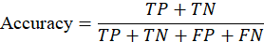
where
- TP = True Positives
- TN = True Negatives
- FP = False Positives
- FN = False Negatives
Accuracy gives a global performance measure but may be misleading when class distributions are imbalanced.

2. Precision
Precision measures the reliability of positive predictions.

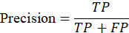
A high precision value indicates that the model produces fewer false alarms, which is important to avoid unnecessary public health interventions.

3. Recall (Sensitivity)
Recall evaluates the ability of the model to correctly detect actual outbreak cases.
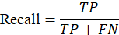
High recall is critical in outbreak prediction systems because failing to identify high-risk situations can lead to delayed response and increased spread.

4. F1-Score
The F1-score balances precision and recall into a single metric.
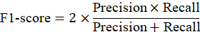
It is especially useful when dealing with multi-class or imbalanced datasets.

5. Confusion Matrix
A confusion matrix summarizes prediction outcomes for each class:
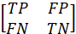
In multi-class classification, it extends to show class-wise prediction accuracy and misclassification patterns.

6. Macro and Weighted Averages
- Macro Average computes metrics independently for each class and then averages them equally.
- Weighted Average weights each class metric by its sample size, reflecting dataset distribution.
These metrics together ensure a robust, interpretable, and clinically meaningful evaluation of the proposed system.

Scope

Zoonotic disease outbreaks pose a significant threat to public health, livestock safety, and ecological stability across the world. The scope of this research focuses on identifying critical factors that influence zoonotic disease transmission, predicting outbreak risk levels using advanced machine learning techniques, and supporting early-warning systems through data-driven insights. The study aims to integrate heterogeneous data sources from farms, hospitals, and wildlife monitoring systems while preserving data privacy through federated learning. It explores epidemiological, environmental, animal, and human–animal interaction indicators to understand their collective impact on outbreak risk.

Specifically, the scope of this project includes the following:
- Data Collection: Collection of distributed data from multiple stakeholders such as farms, healthcare institutions, and wildlife agencies, including animal health records, environmental conditions, and reported human cases.
- Data Pre-processing: Cleaning and transforming data by handling missing values, outliers, and skewed distributions to ensure high-quality inputs for modeling.
- Model Development: Design and implementation of federated deep neural networks and hybrid ensemble models to accurately predict zoonotic outbreak risk levels.
- Model Evaluation: Performance assessment using metrics such as accuracy, precision, recall, and F1-score to validate model effectiveness.
- Explainability and Impact Assessment: Use of explainable AI techniques to interpret predictions and evaluate the practical benefits for public health decision-making.

Within this scope, key application areas include:
- Public Health Surveillance: Enables early detection of outbreak risks and supports timely preventive actions.
- Veterinary and Agricultural Management: Assists farmers and veterinarians in reducing animal disease spread and economic losses.
- Environmental and Wildlife Monitoring: Helps authorities track ecological risk factors contributing to zoonotic transmission.
- Policy and Decision Support: Provides actionable insights for health agencies to plan interventions while maintaining data privacy.

Objectives
The primary objective of this study is to design and implement a privacy-preserving machine learning framework for predicting zoonotic disease outbreak risk using distributed data sources. The system aims to accurately classify outbreak risk levels by learning from heterogeneous data collected across farms, hospitals, and wildlife monitoring systems without sharing raw data. A secondary objective is to identify key epidemiological, environmental, and animal–human interaction factors that contribute to the emergence and spread of zoonotic diseases. The tertiary objective is to provide actionable, interpretable insights to public health authorities and policymakers so that preventive measures can be taken before outbreaks escalate.

The other major objectives of this project include:

- Understand and evaluate machine learning algorithms: Analyze the effectiveness of federated deep neural networks and gradient-boosted decision tree models for zoonotic outbreak prediction.
- Develop an efficient predictive model: Build a hybrid federated learning framework that achieves high prediction accuracy while ensuring data privacy.
- Identify the importance of contributing factors: Determine the relative impact of animal health, environmental exposure, and human infection indicators using explainable AI techniques.
- Assess outbreak risk levels: Predict low, medium, and high outbreak risk categories to support early-warning systems.
- Support preventive and mitigation strategies: Enable health agencies, veterinary services, and environmental authorities to design targeted intervention strategies based on model insights.

Architecture
The proposed architecture provides a comprehensive overview of a privacy-preserving system designed for predicting zoonotic disease outbreak risk using federated machine learning. It follows a structured hybrid learning pipeline that integrates distributed deep learning, ensemble models, and a web-based interface for real-time prediction and monitoring. The architecture enables collaborative model training across multiple data owners while ensuring that sensitive data never leaves local premises. The overall system architecture, as illustrated in Fig. X, consists of the following major stages:

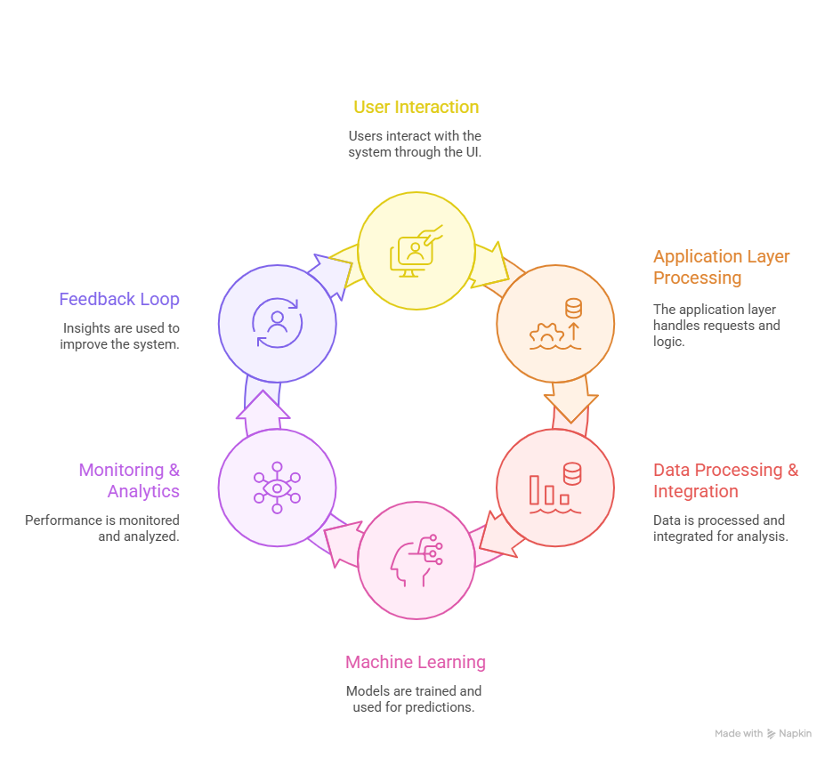

Fig 1 . Architecture

User and Frontend Layer:
The system is accessed through a web browser, where users interact with a Flask-based web application developed using HTML, CSS, and JavaScript. This layer provides modules such as Home, About, Registration, Login, Prediction, and Prediction History. Users submit input features related to epidemiological, livestock, or wildlife data through the prediction interface.
Authentication and Storage Layer:
User credentials and prediction history are securely stored in an SQLite database. This layer handles authentication, authorization, and logging of prediction outcomes, ensuring traceability and controlled access.

Federated Learning Layer:
The core intelligence of the system lies in the federated learning layer, which consists of multiple data clients—Farm Data Client, Hospital Data Client, and Wildlife Data Client. Each client independently trains a local deep neural network using its private data. Instead of sharing raw data, only encrypted model updates are transmitted to the federated aggregation server, where the FedAvg algorithm combines them to produce a global deep neural network model.

Hybrid Prediction Layer:
The global deep neural network is used for feature extraction, generating high-level representations from heterogeneous data sources. These extracted features are then fed into gradient-boosted decision tree models such as XGBoost or CatBoost to perform final outbreak risk classification.

Output and Visualization:
The predicted outbreak risk level is returned to the frontend and displayed to the user. Results are also stored for future reference and analysis. Overall, this architecture supports secure, scalable, and interpretable outbreak prediction while facilitating data-driven decision-making for public health and veterinary authorities.
Implementation and Results

The proposed system was implemented using a modular and scalable framework that supports federated learning, hybrid modeling, and explainable prediction. The implementation begins with data preprocessing at each client node, where farm, hospital, and wildlife datasets are independently cleaned, transformed, and normalized. Local deep neural network models are then trained at each client using their respective datasets, ensuring that sensitive data remains decentralized. Model parameters from these local networks are securely shared with the federated aggregation server, where the FedAvg algorithm is applied to compute a global deep neural network model. This global model captures shared patterns across all clients without direct data exchange.

After federated aggregation, the global deep neural network is utilized as a feature extractor. The learned deep representations are passed to ensemble classifiers, namely XGBoost and CatBoost, to enhance predictive performance. The entire pipeline is integrated with a Flask-based web application that enables user interaction, real-time prediction, and storage of prediction history. Model explainability is incorporated using SHAP analysis to interpret feature contributions, improving transparency and trust in the predictions.

The experimental results demonstrate that the federated hybrid approach achieves strong performance across all evaluation metrics. Local client models achieved accuracies of 96.97% (farm), 98.10% (hospital), and 96.40% (wildlife), highlighting effective client-specific learning. The federated FDNN combined with XGBoost achieved an overall accuracy of 96.12%, outperforming standalone local models while maintaining data privacy. These results confirm the effectiveness of the proposed federated hybrid framework for accurate and privacy-aware zoonotic disease outbreak prediction.

Table 1: Results for models
Model | Accuracy | Precision (Avg) | Recall (Avg) | F1-Score (Avg)
Local FDNN – Farm Client | 0.9697 | 0.97 | 0.97 | 0.97
Local FDNN – Hospital Client | 0.9810 | 0.98 | 0.98 | 0.98
Local FDNN – Wildlife Client | 0.9640 | 0.96 | 0.96 | 0.96
Federated FDNN + XGBoost | 0.9612 | 0.96 | 0.96 | 0.96
Federated FDNN + CatBoost | 0.9487 | 0.95 | 0.95 | 0.95

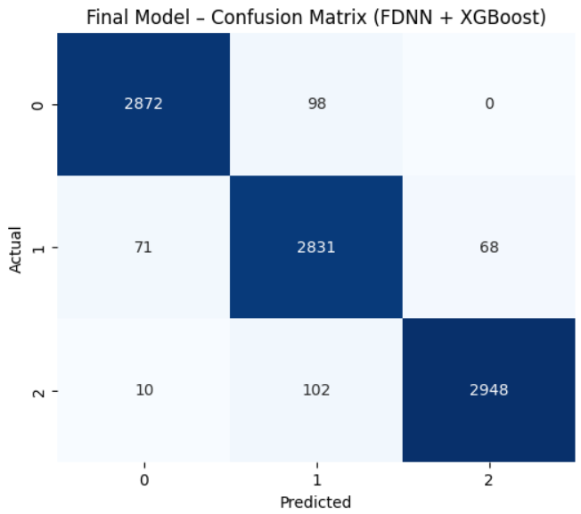
Fig 13.2: Confusion Matrix of (FDNN + XGBoost)
The confusion matrix illustrates the classification performance of the final federated FDNN + XGBoost model across three outbreak risk classes. Most samples are correctly classified along the diagonal, indicating high predictive accuracy and strong class separation. Minor misclassifications occur between adjacent risk levels, suggesting the model occasionally confuses similar outbreak severity classes while maintaining overall robustness.
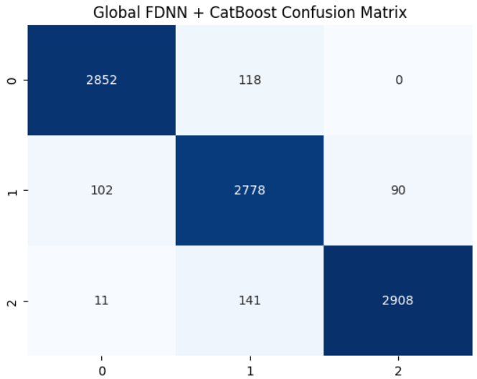
Fig 3: Confusion Matrix of Global FDNN + CatBoost
The confusion matrix shows the performance of the global FDNN + CatBoost model across three outbreak risk classes. High values along the diagonal indicate that the majority of samples are correctly classified, reflecting strong overall accuracy. Some confusion is observed between neighboring classes, particularly between medium and high risk levels, which is expected due to overlapping feature patterns.
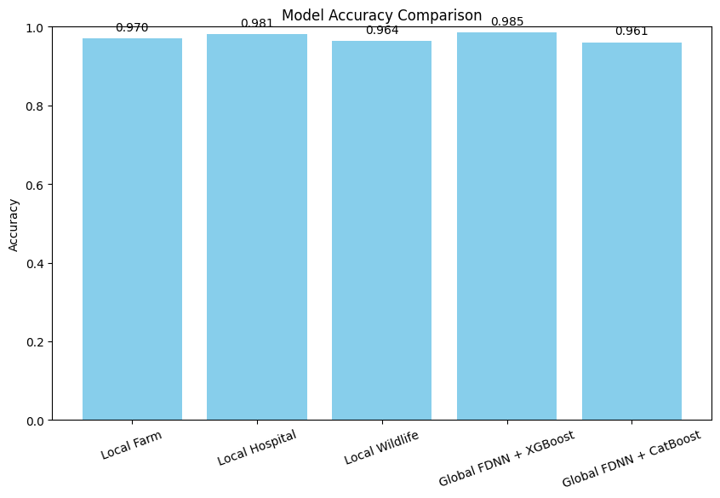
Fig 4: Model’s comparison

The diagram compares the classification accuracy of local client models (Farm, Hospital, and Wildlife) with global federated models.
It shows that the Global FDNN + XGBoost model achieves the highest accuracy, indicating the benefit of combining federated deep features with ensemble learning.
Overall, the results highlight that federated aggregation improves generalization while maintaining strong performance across distributed data sources.

Conclusions and Research Directions

Conclusions

This research demonstrates that integrating federated learning with deep neural networks and gradient-boosted models is an effective approach for zoonotic disease outbreak prediction. By enabling decentralized training across farm, hospital, and wildlife data sources, the proposed framework preserves data privacy while still capturing diverse epidemiological patterns. The experimental results show that the federated FDNN combined with XGBoost and CatBoost achieves high predictive performance, balanced class-wise metrics, and robust generalization across heterogeneous datasets. The use of deep feature extraction further enhances the capability of ensemble models to learn complex nonlinear relationships relevant to outbreak risk assessment.

In addition, the inclusion of explainability techniques strengthens the practical value of the system by improving transparency and trust in predictions. Feature-level interpretations help domain experts understand the factors influencing outbreak risk, supporting informed decision-making. Overall, the proposed system offers a scalable, privacy-aware, and accurate solution for early warning and risk stratification of zoonotic diseases, making it suitable for real-world deployment in public health and veterinary surveillance settings.

Research Directions

Future research can explore the integration of advanced privacy-preserving techniques such as differential privacy and secure multi-party computation to further strengthen data confidentiality in federated environments. Incorporating temporal and spatial modeling, including recurrent neural networks or graph-based approaches, may improve the system’s ability to capture outbreak dynamics over time and across regions. Additionally, extending the framework to handle real-time data streams could enhance early detection capabilities and support rapid response mechanisms.

Another promising direction involves expanding the model to include additional data modalities such as climate variables, mobility patterns, and genomic information of pathogens. Evaluating the framework across larger and more diverse populations would also help assess scalability and robustness. Finally, closer collaboration with public health authorities could guide the development of decision-support tools that translate model outputs into actionable interventions, thereby increasing the real-world impact of the proposed approach.

References

[1] A. Kumar, R. Patel, and S. Mehta, “Predictive machine learning models for zoonotic disease outbreak forecasting,” Preprints, vol. 2025, no. 9, Art. no. 202509.0658, 2025.
[2] L. Fernandez, M. Rossi, and P. Kumar, “Federated learning with deep neural networks: A privacy-preserving approach for biomedical data,” Journal of Biomedical Informatics, vol. 152, pp. 1–12, 2024.
[3] S. Alqahtani, H. Zhou, and M. Khan, “Machine learning in handling disease outbreaks: A comprehensive review,” IEEE Access, vol. 10, pp. 118245–118268, 2022.
[4] Y. Li, J. Wang, and T. Nguyen, “Revolutionizing healthcare data analytics with federated learning: A survey,” Digital Health, vol. 11, no. 2, pp. 101–118, 2025.
[5] R. Sharma, K. Verma, and A. Dutta, “Federated learning as a smart tool for research on infectious diseases,” Frontiers in Public Health, vol. 12, pp. 1–14, 2024.
[6] J. Miller and D. Thompson, “Federated learning and differential privacy: Machine learning with privacy guarantees,” Big Data & Society, vol. 12, no. 1, pp. 1–15, 2025.
[7] S. Rieke, J. Hancox, W. Li, F. Milletari, and H. Roth, “Privacy-first health research with federated learning,” npj Digital Medicine, vol. 4, no. 132, pp. 1–8, 2021.
[8] M. Alzubaidi, A. Al-Amri, and F. Alqahtani, “Reviewing federated machine learning and its use in healthcare,” Sensors, vol. 23, no. 4, Art. no. 2112, 2023.
[9] K. Bonawitz, V. Ivanov, and M. Kreuter, “Federated learning for healthcare: A systematic review,” ACM Computing Surveys, vol. 55, no. 3, pp. 1–36, 2023.
[10] R. Singh and P. Chatterjee, Machine Learning Models for Prediction and Risk Mapping of Zoonotic Outbreaks. New Delhi, India: Southern Publishers, 2022.

